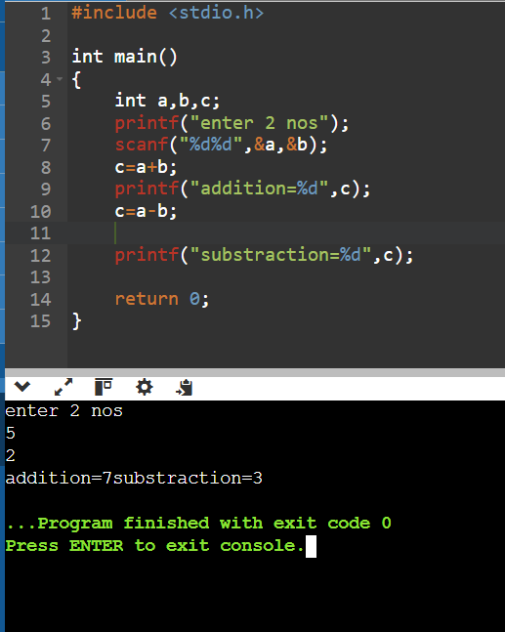 Q1 WAP TO ADD AND SUB OF 2 NOS

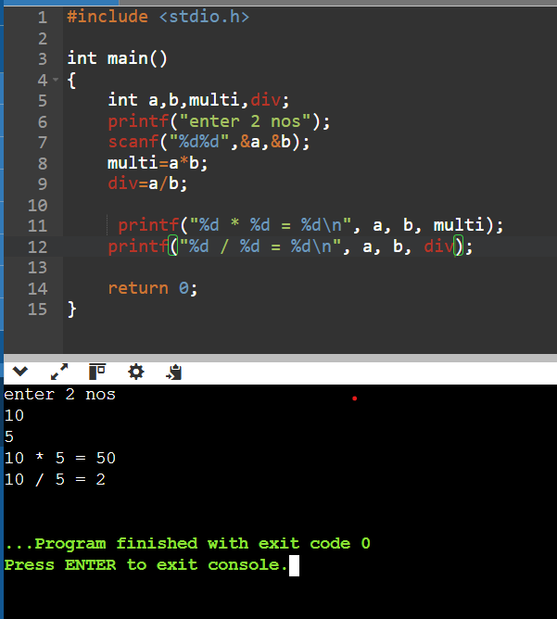Q2 WAP TO MULTIPLE AND DIVIDE TWO NOS AND PRINT THEM IN FORM OF EQUATION (4\*3=12 8/4=2)

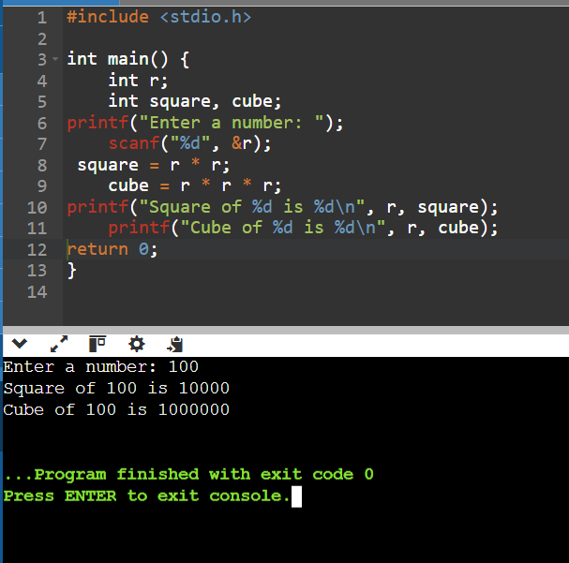Q3 WAP TO FIND THE SQUARE AND CUBE OF A GIVEN NOS

Q4 WAP TO FIND SQAURE ROOT OF A GIVEN NOS USING sqrt () FUNCTION

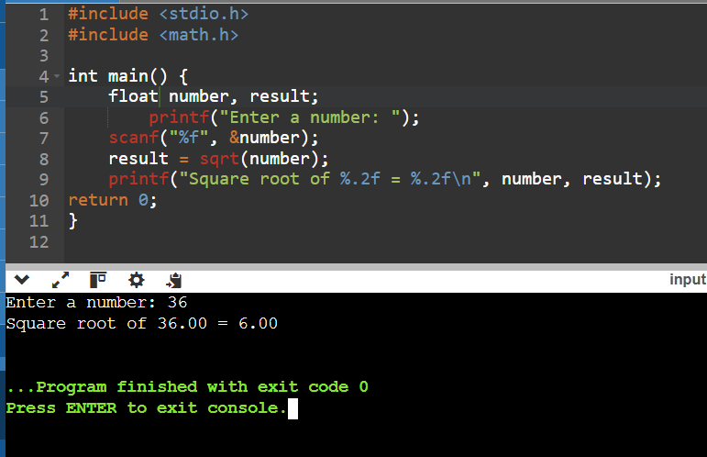

Q5 WAP TO FIND THE AREA AND PERIMETER OF A SQUARE

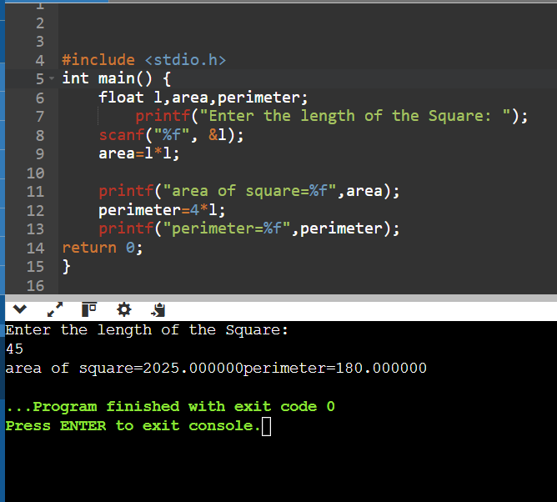

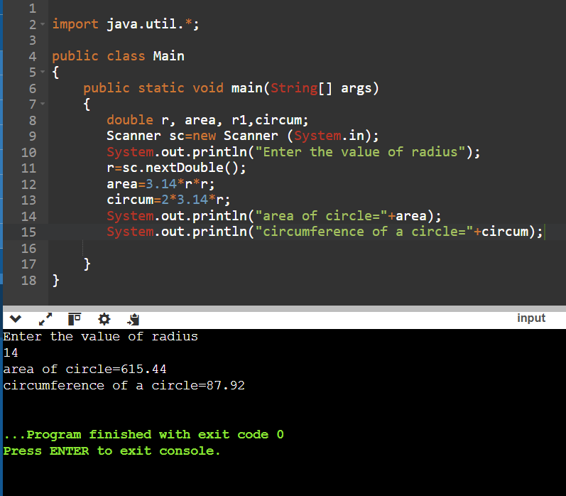Q6 WAP to find the area and circumference of a circle

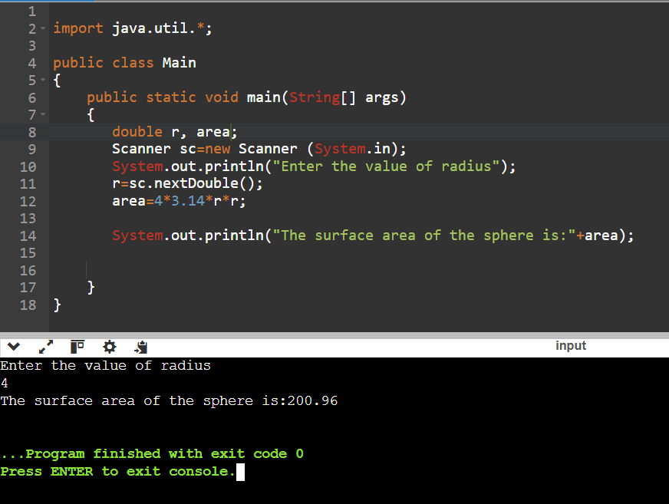Q7 WAP to find the area of a sphere

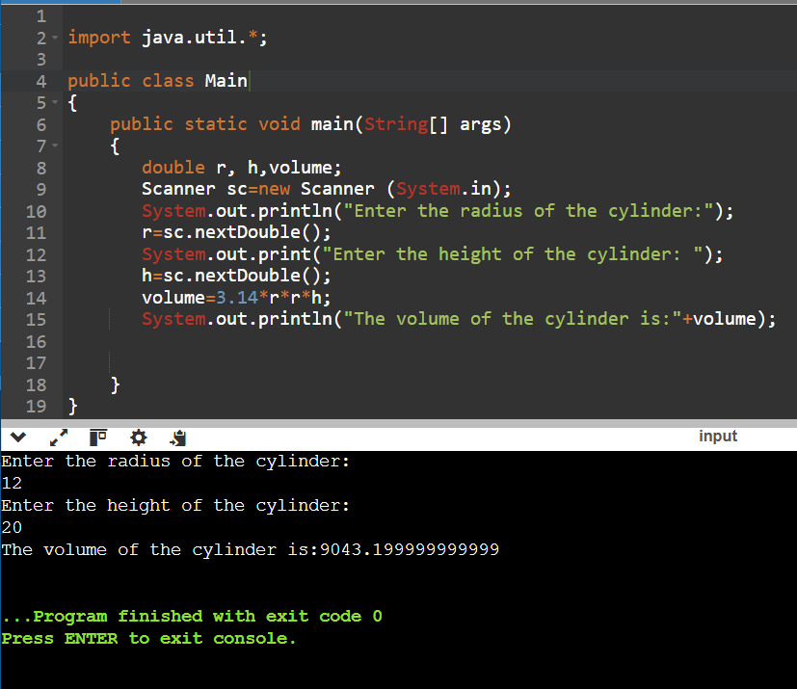Q8 WAP to find the volume of a cylinder

Q9 WAP to find your age in days

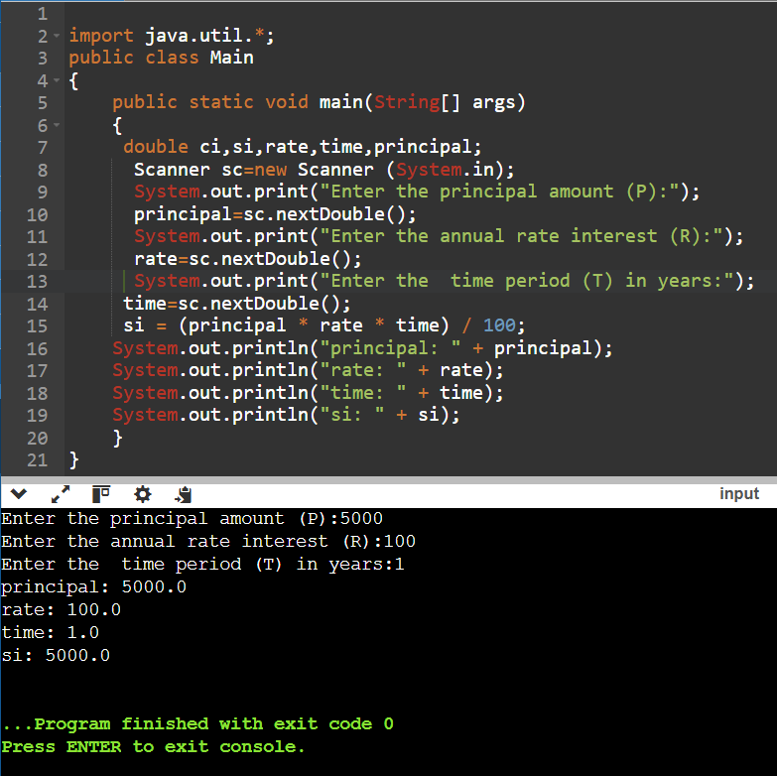Q 10 Write a program to find the simple interest and compound interest

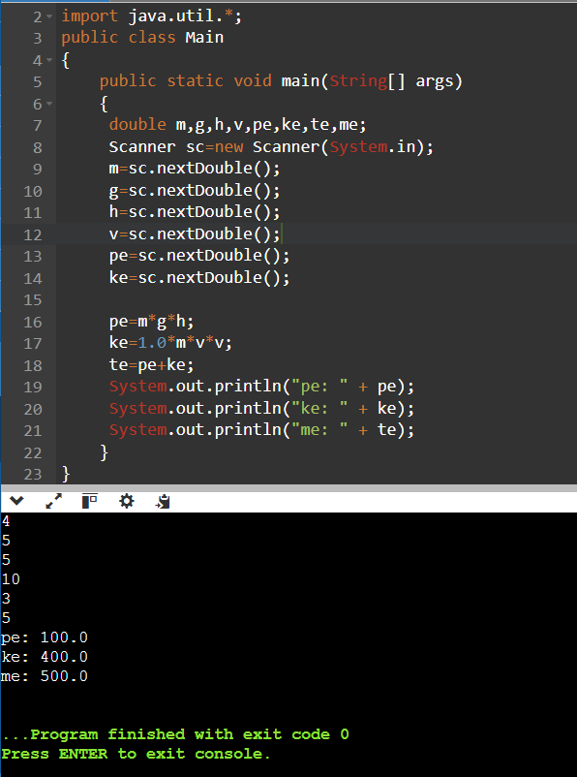Q 11 The total mechanical energy of a particle is given by e=mgh+(1/2) mv^2

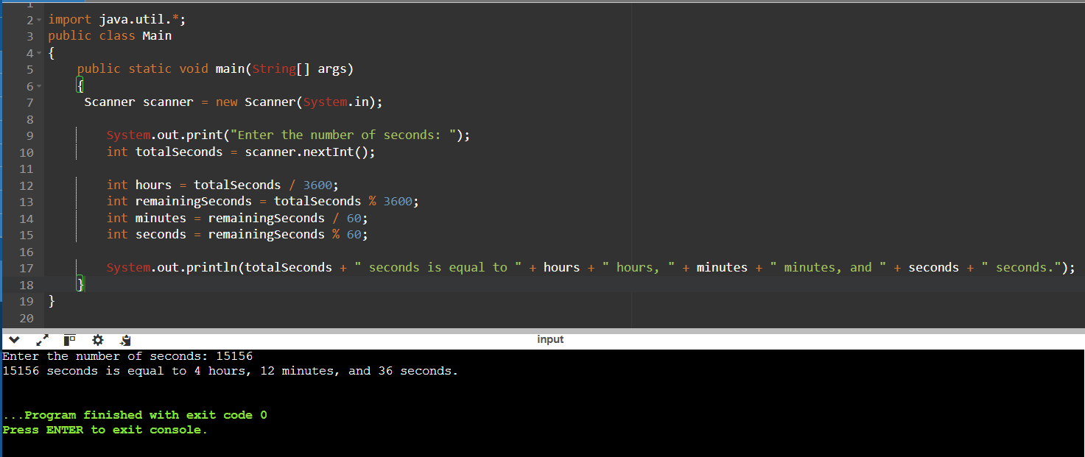

12 Write a program to convert the given seconds into hours–minutes–seconds

Q13 A milk vendor buys milk at the rate of 3.25/- the then adds a liter of water for every 4 liters of milk and sells the water milk at the rate of 4.15/1t. calculate the gain for milk vendor

Q14 The temperature of the city is input through the keyboard in Fahrenheit. Write a program to convert into Celsius

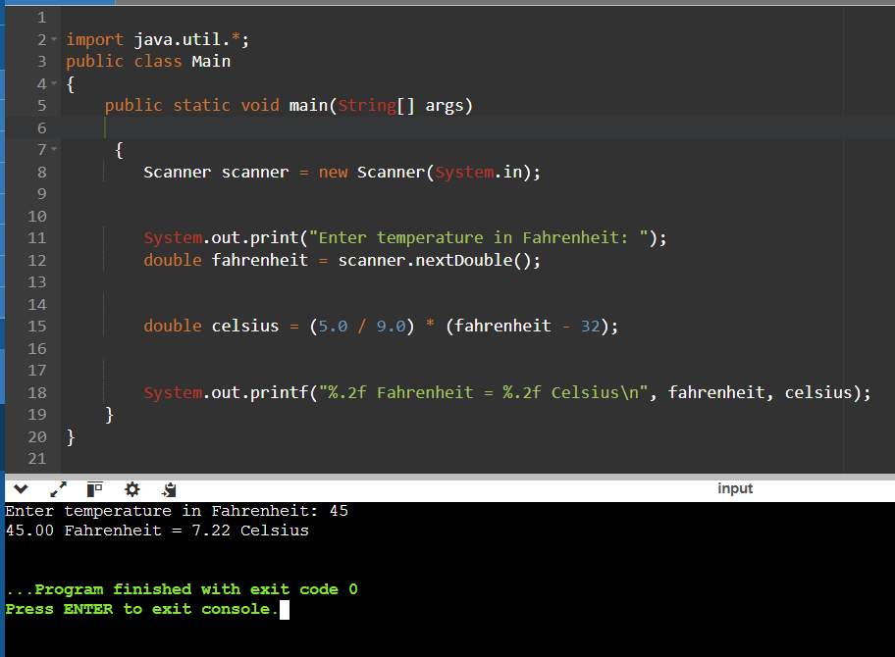

Q15 Two numbers are input into two locations ‘a’ and ‘b’ Write a program to interchange the contents of ‘a’ and ‘b’ without using temporary variables

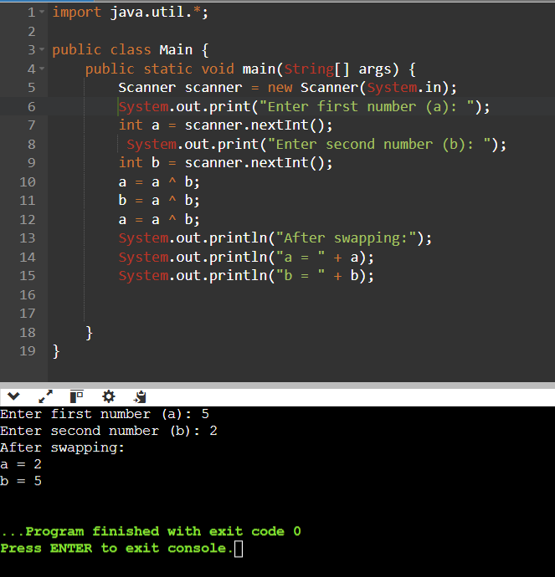

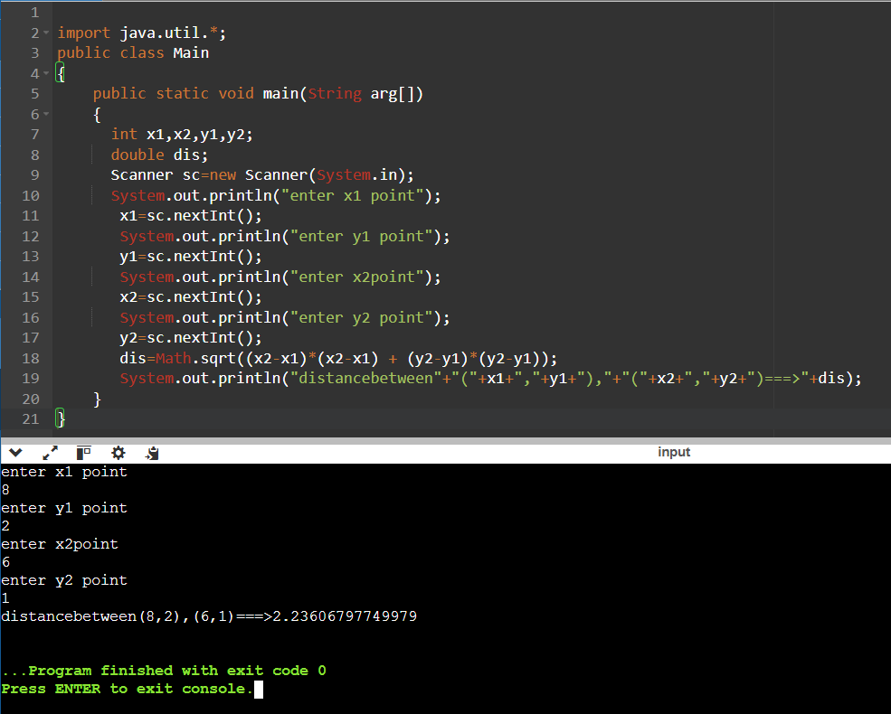Q16 Given the coordinates of two points (x1,y1) and (x2,y2). Write a program to find the distance between these two points?

Q17 Rajesh’s basic salary is input through the keyboard. His D.A. is 40% of basic salary, and H.R.A. is 20% of basic salary. Write a program to calculate his gross salary

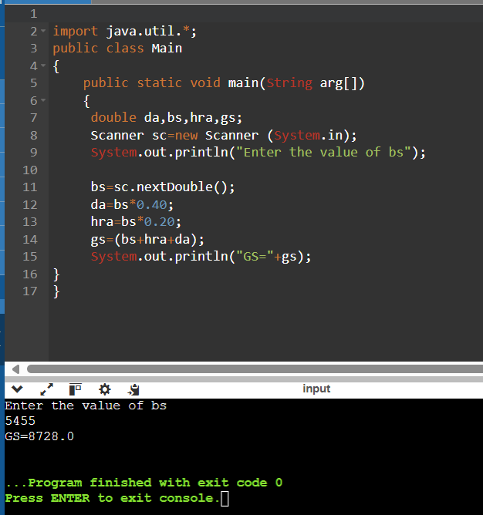

Q18 The distance between two cities in Km. is input through the keyboard. Write a program to convert and print the result in meters and centimeters

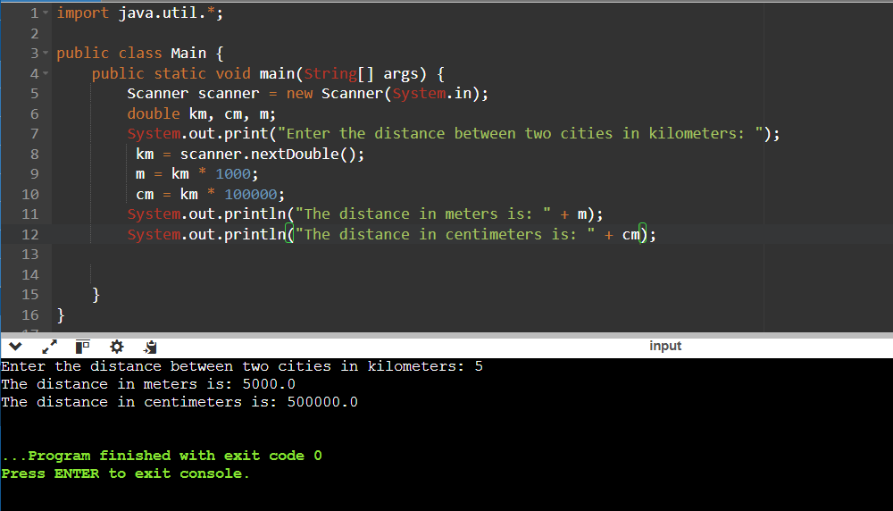

Q19 Write a program which accepts the amount in dollars and convert into rupees

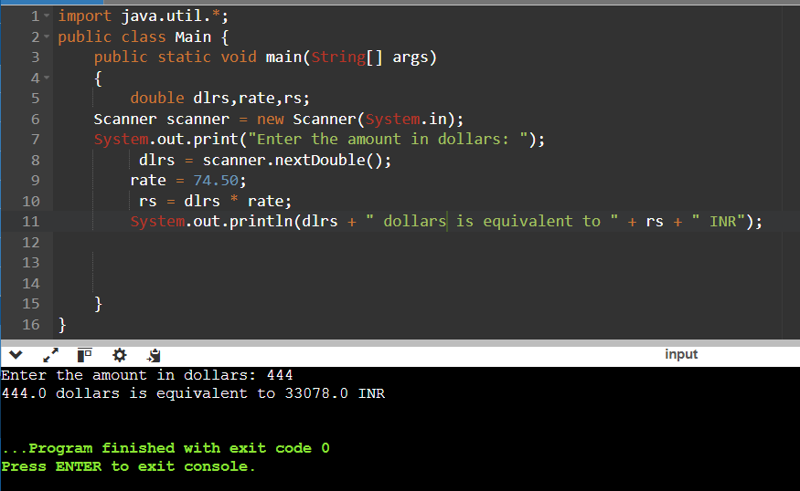

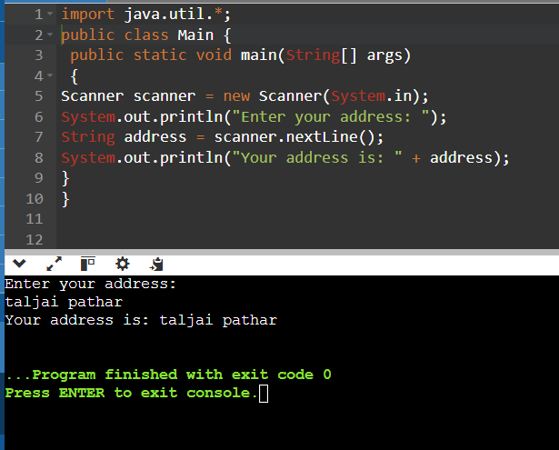Q20 Write a program to read your address and print it

Q21 Write a program to print the area of triangle if b and h values are given

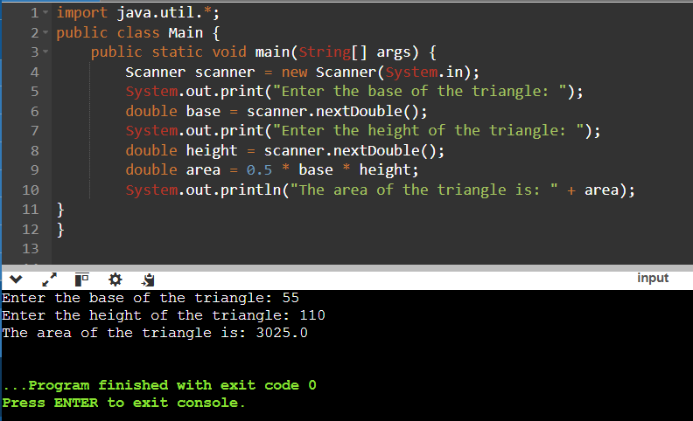

Q22 Write a program to print the area of triangle if three sides are given

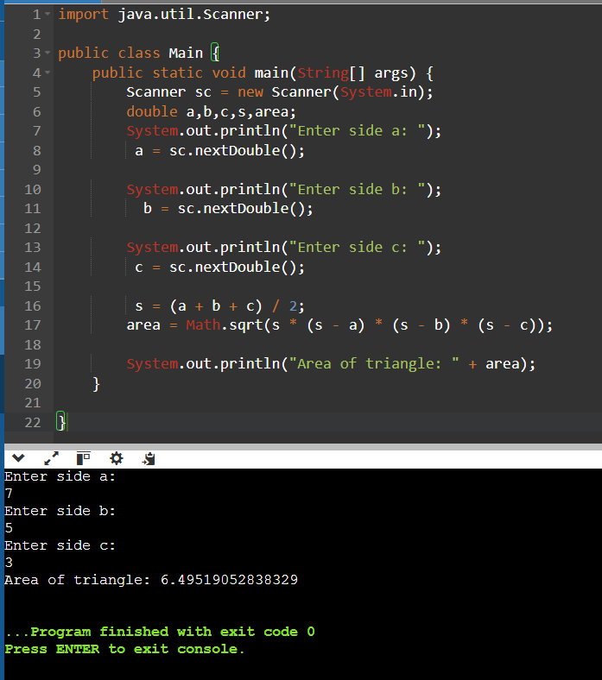

Q23 Write a program to read the marks of 3 subjects and display the total, avg, class

